Reading Comprehension and Creative Writing:
The Carolina Coffee Shop

Skills
- Read and understand informational texts.
- Connect prior knowledge and experiences to text.
- Write informative /explanatory texts to examine a topic and convey ideas and information clearly (through the selection, organization, and analysis of relevant content).
- Write narratives to develop real or imagined experiences or events using effective technique, (relevant) descriptive details, and clear/well-structured event sequences.
- Gather relevant information from multiple print and digital sources, assess the credibility and accuracy of each source.
Read the short informational texts below and enjoy discussing and writing the answers to the questions about the material.

Selection 1: From the Chapel Hill/Orange County Visitors Bureau

Text typed below for easy reading

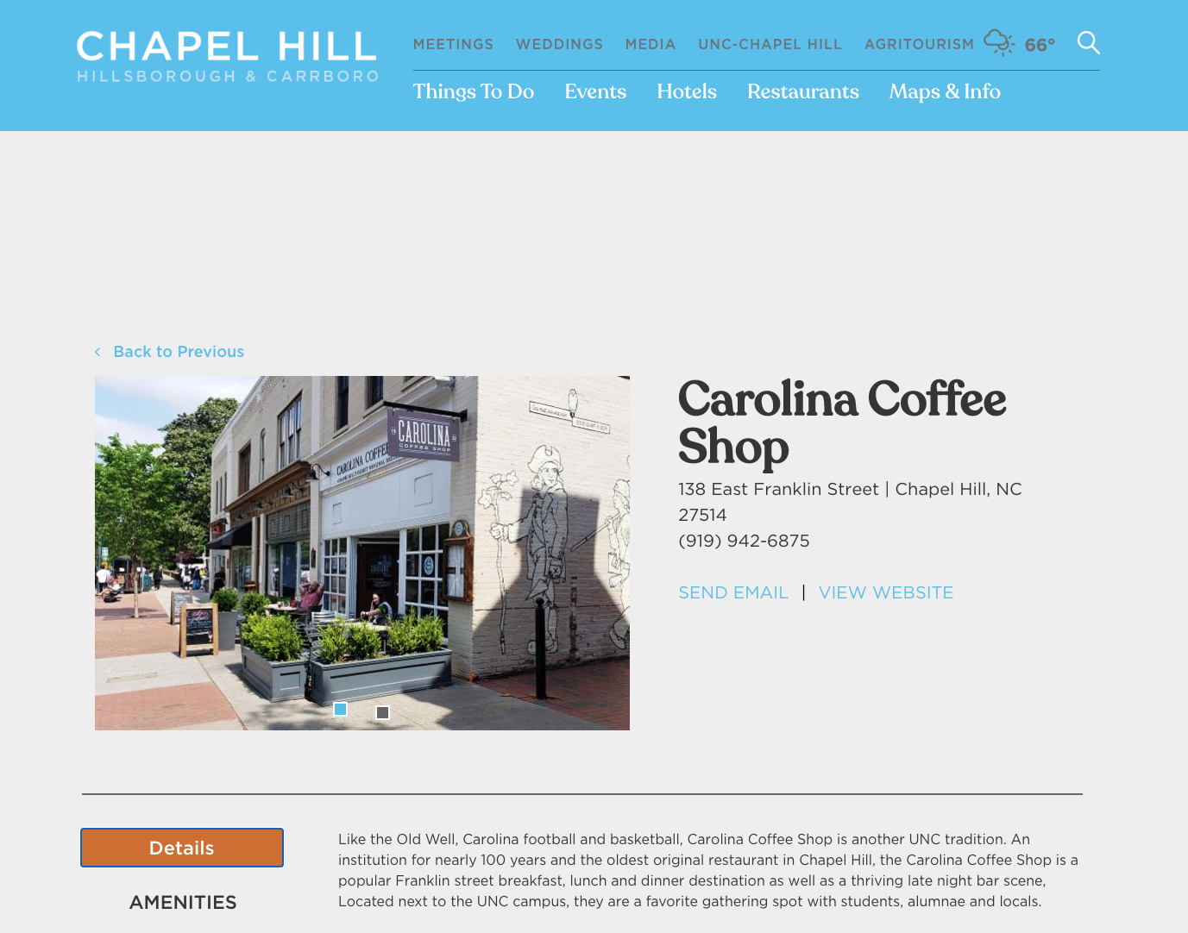

“Like the Old Well, Carolina football and basketball, Carolina Coffee Shop is another UNC tradition. An institution for nearly 100 years and the oldest original restaurant in Chapel Hill, the Carolina Coffee Shop is a popular Franklin street breakfast, lunch and dinner destination as well as a thriving late night bar scene, Located next to the UNC campus, they are a favorite gathering spot with students, alumnae and locals.”

Selection 2: Short piece originally printed in Classic Restaurants of Chapel Hill and Orange County

Carolina Coffee Shop

Of all of Chapel Hill’s restaurants, one has a claim to fame grander than all the rest: Carolina Coffee Shop is the oldest continually running restaurant in North Carolina. For nearly a century, as of this writing, it has been a student tradition, as well as a required place to visit for generations of returning alumni.
In a building that once housed a student post office, Carolina Confectionary opened in 1922. It served candy, sodas, and sandwiches. In 1928, George Livas and James Gust purchased the establishment and renamed it the Carolina Coffee Shop. Livas continued to run it until his death in 1956. Another local restaurateur then ran the business for a couple of years before Byron Freeman took over. He went on to operate it for more than forty years before selling it to Greg Owens. In 2018, a group of UNc graduates, including Olympic soccer star Heather O’Reilly, took over ownership. “It’s in such a great location here on Franklin Street and I think that when you close your eyes and imagine Franklin Street, you imagine it with a Carolina Coffee Shop, “ O’Reilly told the Daily Tar Heel. “ I have that etched in my mind as a staple of the town and the street.” Serving what it describes as “southern food with a modern twist, “ Carolina Coffee Shop remains an integral part of the Chapel Hill experience for both students and visitors.

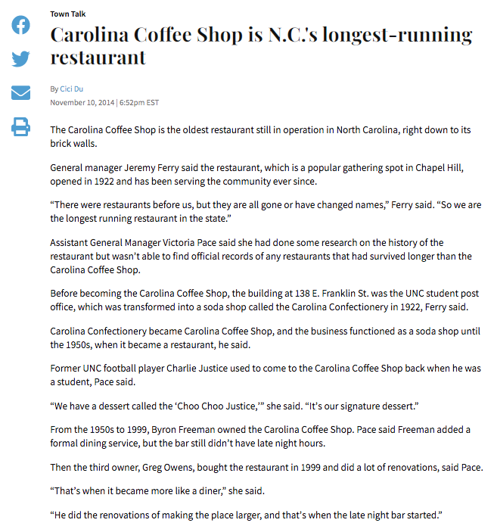
Selection 3: From The Daily Tar Heel online
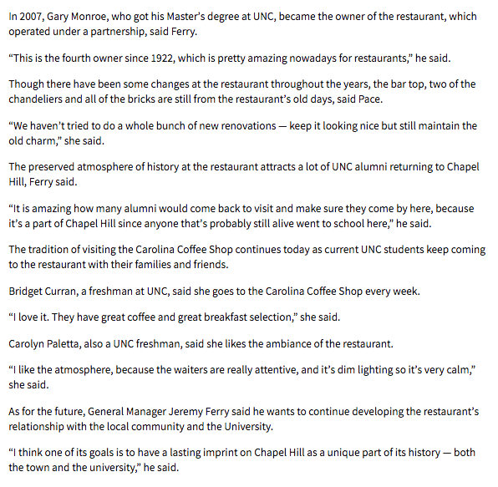

Discussion questions
- In the first reading selection, what words provides clues as to the meaning of the word ‘alumnae’?

- Why do you think the Carolina Coffee Shop had its name changed?

- The first sentence in the first selection talks about a ‘claim to fame’. What do you believe a ‘claim to fame’ means? Do you have a ‘claim to fame’?

- The second selection calls the Carolina Coffee shop a ‘UNC (University of North Carolina) tradition? What does the word tradition mean to you? What traditions do you or your family or friends have? Can you think of any other traditions where you live?

- The third piece describes the Carolina Coffee Shop’s signature dessert. If you had a dessert named after you, what would it be, what would it be named, and why?

- Do you think they still serve the same food as they did before? Why or why not?

- How do you think people’s favorite food and rinks change over time, and what might influence those changes? What influences you when you think of your favorite foods and drinks?

- Now that it is easier and cheaper to import goods from different countries, we eat a variety of different things. What impact might the lack of easy import had on the types of food offered at the Carolina Coffee shop and other older restaurants?

- Why do you think this restaurant has survived for so long?

Creative writing

- Choose a time period and write about what it may have been like to visit the Carolina Coffee Shop and Franklin Street. You could choose the 1920s, or the 1960’s, or even today! You can write a first person fiction piece, or a non-fiction piece. For example, what sort of people and vehicles went past the windows? What sort of music would have been playing? What would the menu have and how much do you think you would pay for the food?

- Imagine you had your own restaurant or café. What would you name it and what would your logo be? What sort of decorations would you have? What food or drinks would you serve? Would there be anything special, different, or fun about your place that makes it more exciting than other places? How could you make sure that it survived for a hundred years (or more!), like the Carolina Coffee Shop?

Bibliography

- Chapel Hill/Orange County Visitors Bureau (2021) Carolina Coffee Shop (March 27.2021) < https://www.visitchapelhill.org/listing/carolina-coffee-shop/166/>

- Du, Cici (November 10, 2014), “Carolina Coffee Shop is N.C.’s longest-running restaurant”, The Daily Tar Heel (March 27,2021) <https://www.dailytarheel.com/blog/town_talk/2014/11/carolina-coffee-shop-1111#:~:text=Franklin%20St.,became%20a%20restaurant%2C%20he%20said>

- Holaday, C., Cullum, P. (2020) “Carolina Coffee Shop”, Classic Restaurants of Chapel Hill and Orange County. American Palate. pp.61-64.

