Native American Folktale Study Grades 1-3, 5 with adaptations
Objective:
Students will use the Native American folk tale of ‘Why Corn Husk Dolls Have No Faces’ to explore how cultural beliefs and identities are revealed through oral folklore traditions.
Standards:
- 1.G.2.2 Explain how people use natural resources in the community.
- 1.H.1.2 Explain the importance of folklore… and (its) impact on local communities.
- RL.2.2/ RL.3.2 Recount stories, including fables and folktales from diverse cultures, and determine their central message, lesson, or moral and explain how it is conveyed through key details in the text.
- RL.3.3 Describe characters in a story and explain how their actions contribute to the sequence of events.
- 5.C.1.4 Understand how cultural narratives (legends, songs, ballads, games, folktales and art forms) reflect the lifestyles, beliefs and struggles of diverse ethnic groups.
Associated Vocabulary:
Folklore - legends, music, oral history, jokes, popular beliefs, fairy tales, and customs that are traditions of a culture or group
Folktales – stories originating in popular culture, often passed on through the oral tradition
Theme – the subject or underlying meaning that a literary text directly or indirectly explains, develops, and/or explores.
Central message – the unifying concept within a text to which other elements and ideas relate
Key details – specific and important parts of the text that provide information, support, and elaboration
Major events – the most important events that occur within a literary work

Accommodations:
This lesson can be scaffolded so that very young students or slightly older students can enjoy and interact with it. Some of the included activities would be more appropriate for older learners, while younger learners can discuss questions out loud or draw pictures to retell this story or make their own folktale.

Cross Curricular Considerations:
RELA: Story plot including climax and resolution, character study, retelling a story in order, main idea/theme and key details
Science: Pollination, life cycle of a plant, numerous uses of corn from ethanol to livestock feed as a renewable resource
Social Studies/Economics: Importance of corn as an agricultural resource, land use and human changes to the land through farming
Introduction and Exploration:
Students will listen to or read the Native American folktale “Why Corn Husk Dolls Have No Faces” on page 3, and discuss using the following questions
Explanation and Elaboration:
Students will read or listen to information on page 4 about folklore in general and its cultural significance, as well as what this particular folktale reveals.
Activities:
Students can engage in one or more of the following activities on page 6 both to extend and show their understanding of the story individually and as a piece of folklore, and to show their understanding of story structure, characters, and the cultural importance of folklore. Additionally, there are instructions on how to make your own cornhusk doll.

Introduction

Today you will hear a Native American folktale, a story that was passed down through many generations, with elders telling the tale to younger members. When you hear and read it, think about what the words and the story means-and think about what else the story may be trying to reveal to us.

Why Corn Husks Dolls Have No Faces

A long time ago, the Spirit of the Corn wanted to play with the children of the tribe, so she made little dolls out of her very own corn husks-the papery leaves that grew around her corn. But, she made these dolls very beautiful, just like her. Their faces were so pretty, that she stared and stared at them. She spent all day looking at their beautiful faces, and ignored the children. To punish her for being so self-absorbed and ignoring others, her face was taken away. That is why even today cornhusk dolls have no faces.

Exploration

- Who were the characters in this story?
- What happened to them?
- Why do you think the story ended this way?
- What do you think we are meant to remember from this story?
- How is this story supposed to make us change our ways?
- How would this story be used as a lesson to younger members of the tribe?

Explanation and Elaboration

- The theme, or central message, of this folktale is that you should not be too vain or take too much pride in the way you look, especially when you do it so much that you end up ignoring other duties and those around you. Instead, you should appreciate those around you, and not spend so much time always worried about the way you look.
  - We can tell that this culture valued being humble and caring for others and spending time with them. This folktale is a way to teach the importance of staying humble about your appearance, and the bad consequences that can happen if you are too vain.

- This story is considered a folk tale. A folk tale is a story or a legend that is told orally, out loud, and passed down through generations. They are meant to teach a lesson about how, or how not, to behave in ways that are easy to remember. They also reveal clues about the culture and people who tell them by revealing what everyday life was like, and the sorts of issues or problems people of that culture dealt with. Usually, there is a good character and a bad character, and it is very obvious which is which. Almost always, goodness is rewarded.

- By listening to this story, we can learn about Native American culture. We can tell that corn is an important resource for them, and that they use it in many ways. The tale shows that they value each member of the tribe and live together in groups that care for one another. We can also see that they are not wasteful, as they are using every part of the corn in some way. By telling this story, you are not only passing down moral beliefs, but also sharing cultural practices and ways of living.

- You can see real cornhusk dolls that were made by a tribal member of the Occaneechi Band of the Saponi Nation at the Orange County Historical Museum. She made them and their little clothes very carefully by hand- and she dyed one of them pink using Kool-Aid!

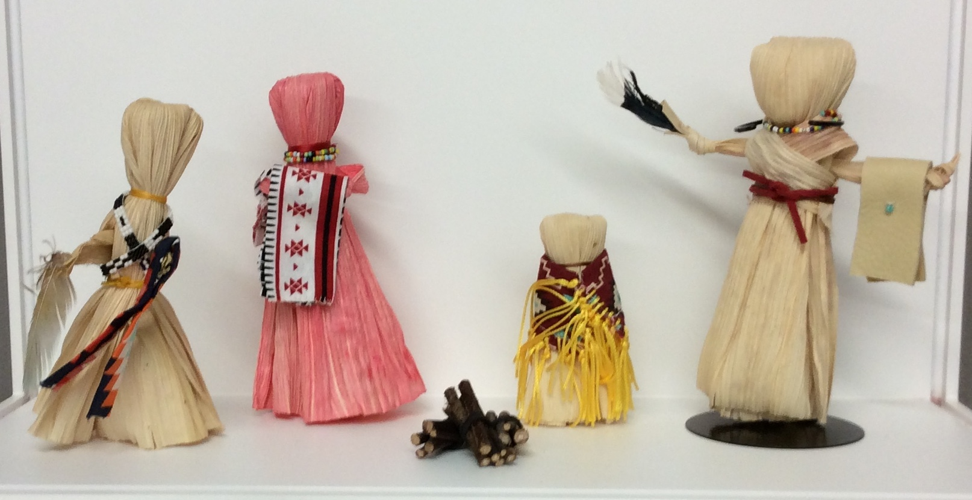

Questions and Activities

Discussion Questions

- Which parts of the story help you understand when and where this story takes place?

- Which parts of the story help you understand the culture?

- How would this story have taught people who heard it a lesson? What lesson was it meant to teach?

- What values, believes, and attitudes does this story show the Occaneechi tribe valued?

- Why would it be important to keep telling this story for generations?

Activities

- Draw a comic strip illustrating the folklore. Be sure to include all the characters and main plot points.

- Write a few sentences and/or draw a picture of the main character and what happens to her in the story. Be sure to use as much description as you can.

- Retell or rewrite the story using your own words.

- Retell or rewrite this story as if it were taking place in our society and culture today.

- Your own folktale! Write and illustrate, draw a comic, or make a video acting out your own folklore story!
Folktales are:
  - Short and easy to remember and tell others orally, or out loud
  - Meant to teach people a lesson about moral (what is right and wrong) or beliefs (how people and cultures act, behave, and what they consider important)
  - Could explain how and why something exists (why corn husk dolls have no faces, how the camel got it’s hump,).
  - Could involve animals, or non-living things such as wind or water, that can talk.
  - Not necessarily about a real thing that happened, it is a piece of fiction.

How to Make a Corn Husk Doll

Materials
- Square-cut dried corn husks ($7.43 for 6 oz., amazon.com)
- Wool felt in assorted colors ($3 per sheet, achildsdream.com)
- Yarn or raffia
- Paper towel
- Buttons
- Scissors ($20.99, michaels.com)
- Glue

Steps
- Start by soaking the husks in water for 10 minutes, and then blot excess water with a paper towel.
- Lay four or six husks (always an even number) in a stack.
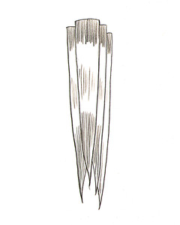

- Using thin twine, tie husks together, about 1 inch from the top.
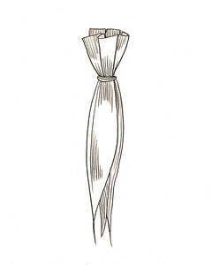
- Separate husks into equal portions (2 and 2, or 3 and 3), and fold halves down, covering twine.
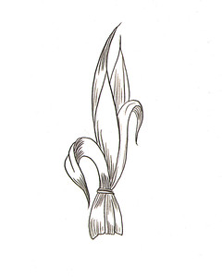

- Using thin twine, tie husks about 1 inch down, creating the head.
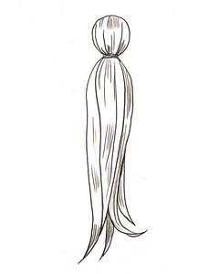
- Roll a single husk and tie at the ends to make arms.
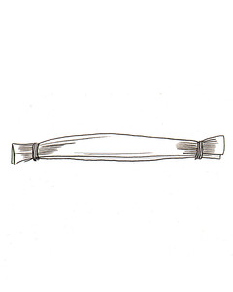

- Position arms below the knot at neck, between equal portions of husks.
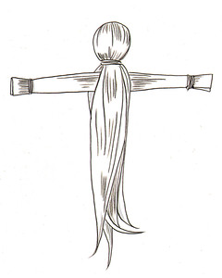
- Tie waist. For a doll wearing a dress, trim husks to an even length.
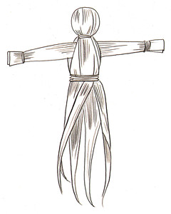

- For a doll wearing pants, separate legs into equal portions. Tie at knees and ankles. Trim evenly.
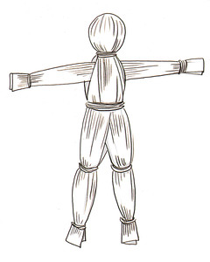
- To make the hair, glue the yarn or raffia to the heads. Fashion clothes from pieces of felt: Cut rectangles, and snip slits or X's in the center; then slide over the doll's head, and secure around the waist with a strip of felt or yarn. (Glue on buttons, and use scissors to make fringe as desired.) Create hats and bonnets by cutting felt to fit, and then gluing in place.

